**Boost Your Immunity Naturally with Organic Nation’s Wild Forest Honey**

The immune system is your body's natural defense against infections. Supporting it with the right foods can make a big difference. One of nature’s best immunity boosters is [**wild forest honey**](https://organicnation.co.in/shop/organic-honey/Organic-Wild-Forest-Honey). Unlike processed varieties, this pure honey is packed with nutrients and bioactive compounds that help strengthen your body.

In this article, we’ll explore how **organic honey** can enhance your immune system, the best ways to consume it, and why it’s better than processed honey.

**Why Wild Forest Honey is a Powerful Immunity Booster**

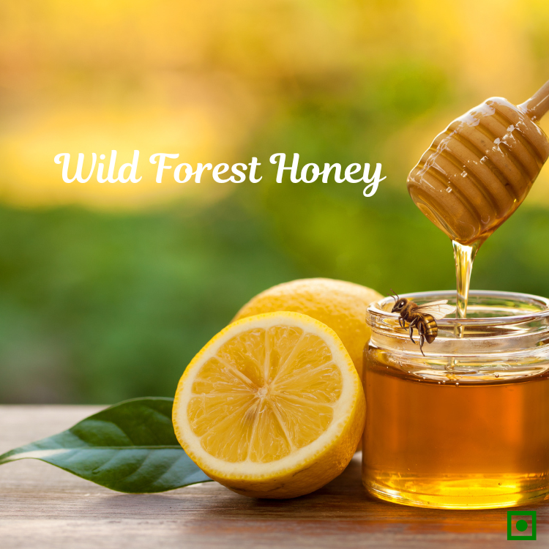

**Packed with Natural Antioxidants and Enzymes**

Wild forest honey contains high levels of antioxidants, which protect your cells from damage caused by free radicals. These antioxidants, such as flavonoids and polyphenols, help reduce inflammation and boost immune response.

Enzymes in **organic honey** also play a role in breaking down harmful bacteria and strengthening gut health, which is crucial for a strong immune system.

**Rich in Vitamins and Minerals for Better Health**

Unlike processed honey, wild forest honey is loaded with essential vitamins and minerals such as vitamin C, iron, magnesium, and potassium. These nutrients help the body fight infections and support overall well-being.

Regular consumption of **pure honey** ensures that your body receives the right nutrition to function optimally, making you less susceptible to common illnesses.

**Antibacterial and Antiviral Properties for a Stronger Body**

One of the key benefits of **wild forest honey** is its natural antibacterial and antiviral properties. Studies have shown that honey can help fight harmful bacteria, including those responsible for respiratory infections.

Consuming honey regularly can prevent seasonal colds, flu, and other infections while soothing a sore throat naturally.

**Best Ways to Consume Wild Forest Honey for Maximum Benefits**

**Mix It with Warm Water and Lemon**

A simple yet effective way to enjoy the benefits of wild forest honey is by mixing it with warm water and lemon. This combination helps detoxify the body, supports digestion, and provides a natural immunity boost.

**Add It to Herbal Teas**

Herbal teas, such as ginger or chamomile tea, pair well with [**pure honey**](https://organicnation.co.in/). Adding a spoonful of honey enhances the flavor while providing additional antibacterial properties that help fight infections.

**Use It as a Natural Sweetener**

Replace refined sugar with **organic honey** in your daily diet. Whether added to oatmeal, yogurt, or smoothies, honey serves as a healthier alternative that also strengthens the immune system.

**Organic Honey vs. Processed Honey – Which is Better?**

**The Nutritional Differences**

Organic honey retains its natural nutrients, including enzymes, vitamins, and minerals, while processed honey is often heated, destroying these beneficial compounds.

**How Processing Affects Honey’s Health Benefits**

Commercially processed honey often undergoes filtration and pasteurization, stripping it of essential nutrients and antioxidants. As a result, it loses much of its immunity-boosting power.

**Why Choosing Pure Honey Matters**

Opting for raw, **wild forest honey** ensures you get the full range of health benefits without added preservatives or artificial sweeteners.

**Additional Health Benefits of Consuming Wild Forest Honey**



**Supports Digestion and Gut Health**

Honey is a natural prebiotic that nourishes good gut bacteria. A healthy gut microbiome plays a vital role in overall immunity and digestion.

**Helps in Wound Healing and Skin Care**

Due to its antibacterial properties, honey is an excellent natural remedy for healing minor cuts and wounds. It also works as a moisturizing agent for the skin.

**A Natural Remedy for Cough and Sore Throat**

Honey has been used for centuries to treat coughs and soothe sore throats. Mixing honey with warm water or herbal teas provides instant relief from throat irritation.

**Conclusion – Make Wild Forest Honey a Part of Your Daily Diet**

Incorporating **wild forest honey** into your daily routine is an easy and delicious way to boost immunity naturally. From fighting infections to improving digestion and skin health, this superfood offers numerous benefits.

Choose [**organic honey**](https://organicnation.co.in/shop/organic-honey) over processed varieties to get the best results. Start adding a spoonful of this golden elixir to your meals and enjoy the health benefits it brings!